Chapter 1: Science toolkit

1.1 Science is the study of the natural and physical world

Literacy support worksheet answers (pages 2–3)

What is science?

1 Look at the different types of scientists in the box below. Match each type of scientist to the situation they would be best able to investigate.

a A species of coral living in the Great Barrier Reef is dying unexpectedly.

A marine biologist would investigate this.

b A fossilised ancient kangaroo has been discovered in the Simpson Desert.

A palaeontologist would investigate this.

c An area of the Wilson’s Promontory National Park is drying out due to climate change.

An environmental scientist would investigate this.

d There is a possible tropical cyclone threat to northern Queensland.

A meteorologist would investigate this.

e A drug is needed to treat a new strain of the Avian Bird Flu that has reached Australia.

A pharmacologist would investigate this.

f A scientific theory that viruses could generate electricity needs to be researched.

A nanotechnologist would investigate this.

2 Describe what the scientist in the photograph might be doing.

Student responses will vary but could refer to the sampling of water, studying the organisms or chemicals in the water and examining stream temperature or turbidity.

WORD DETECTIVE

3 Crossword

Read the clues below and complete the crossword.

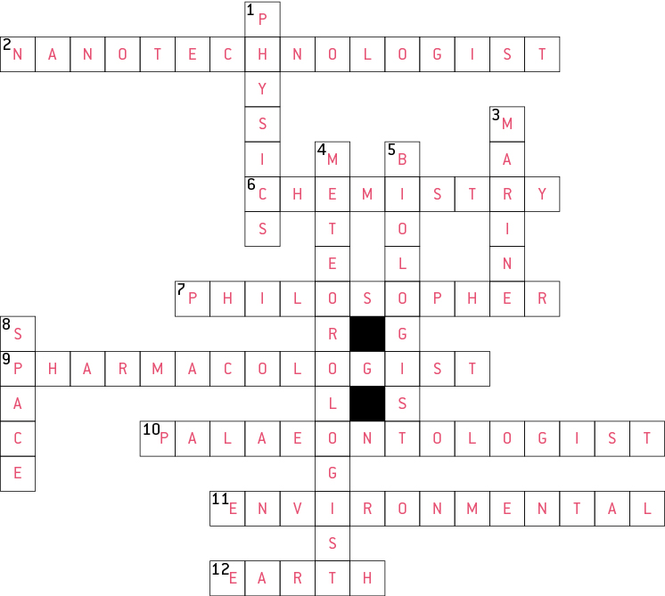

1.2 Scientists use specialised equipment

Literacy support worksheet answers (pages 4–5)

Lab equipment

This worksheet could be completed as a quiz or you could use it to revise the various types of specialised equipment used in the science laboratory.

1 Below are a series of scientific diagrams. Write the name of the scientific equipment and a short description of how the equipment is used next to the diagram in the space provided.

a Equipment: beaker

Used for: containing liquids

b Equipment: retort stand and boss head clamp

Used for: holding a probe or thermometer in a beaker

c Equipment: measuring cylinder

Used for: accurate measurement of liquids

d Equipment: Bunsen burner

Used for: heating substances

e Equipment: stirring rod

Used for: stirring substances

f Equipment: gauze mat

Used for: placed on a tripod over a Bunsen burner

g Equipment: evaporating dish

Used for: allowing liquids to evaporate from dissolved solids

WORD DETECTIVE

2 Match-a-word

Match the following words with the relevant pictures.

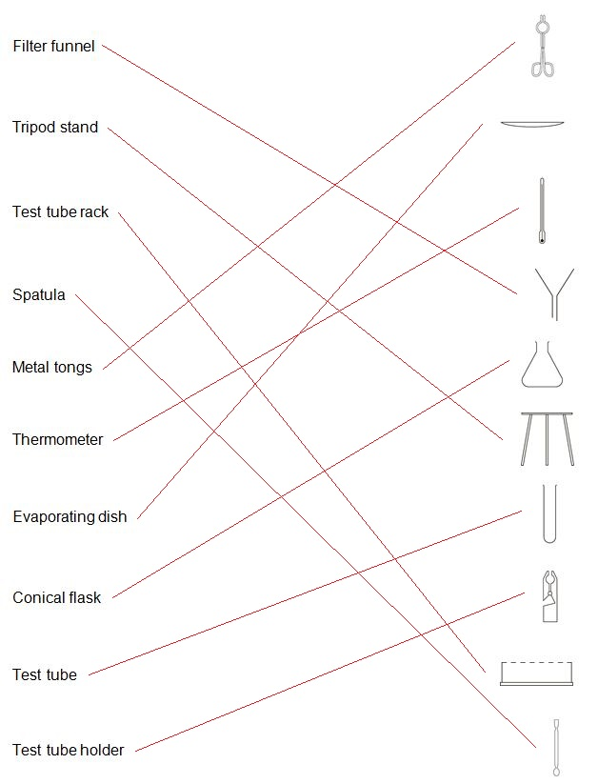

1.3 Scientists take safety precautions

Literacy support worksheet answers (pages 6–7)

Safety in the lab

1 Read the dot points on what happened in the laboratory and write ‘do’ or ‘don’t’ next to each one.

• Connie listened carefully to her teacher explaining the experiment

Do

• Rod put his earphones in while the teacher was explaining

Don’t

• Rod put on his lab coat, but didn’t button it up

Don’t

• Connie didn’t put on a lab coat because it didn’t match her outfit

Don’t

• Connie didn’t tie her hair back

Don’t

• Both of them wore safety glasses

Do

• They put their textbooks under their desk

Do

• They left their workbooks on the desk

Don’t

• They put the Bunsen burner, tripod and gauze mat onto a bench mat

Do

• They put the Bunsen Burner next to the gauze mat

Don’t

• They lit the Bunsen Burner then walked away and chatted to friends

Don’t

• Rod accidentally knocked the beaker on the floor and told his teacher

Do

• They put the equipment away while it was still warm and burned their hands

Don’t

• Connie washed her hands afterwards

Do

• Rod forgot to wash his hands

Don’t

• They put their coats away

Do

• They left their safety glasses on the bench

Don’t

2 This symbol means that corrosive materials such as acids and bases are present. What do you think the picture is of?

The picture shows chemicals being poured out of test tubes and burning metal and someone’s hand.

3 Why would it be needed in a science laboratory?

This symbol would be needed in the science laboratory because corrosive chemicals are used here.

WORD DETECTIVE

4 True or false?

Read each statement below and circle T if it is true or F if it is false.

a Disposable gloves need to be worn during experiments

T

b Gases or mixtures of chemicals need to be smelled when experimenting

F

c Laboratory coats need to be worn at knee length

T

d Safety glasses always need to be worn when mixing chemicals

T

e Sandals can be worn when doing experiments

F

f It doesn’t matter how your hair is worn when experimenting

F

g Matches, paper and other substances need to go down the sink

F

h Eating is not allowed in the laboratory

T

i Vulcanologists wear heat resistant silver suits

T

i Chemicals are often mixed at random when experimenting

F

Now make up some true or false questions for a friend.

Student answers will vary.

1.4 Scientists use observation and inference to answer questions

Literacy support worksheet answers (pages 8–9)

Observation and inference

1 Beside each of the following observations, write the symbols QL (for qualitative observation) or QT (for quantitative observation).

a The liquid was very hot:

QL

b The mouse was 4.5 centimetres long:

QT

c The ball was travelling at 1 metre per second down the slope:

QT

d I heard the chemicals fizzing:

QL

e It took 6.7 seconds for the metal to dissolve:

QT

f The chemical reaction caused a 76.3°C increase in temperature:

QT

g I could smell the sulphur dioxide during the experiment:

QL

h The surface of the bench felt rough:

QL

i The substance turned blue when it was heated over the Bunsen burner:

QL

j The 50 millilitres of water evaporated from the beaker:

QT

2 What are two reasons why you should not smell things in a test tube unless your teacher instructs you to?

Student responses will vary but could include the substance may be toxic, corrosive, very hot, irritating, cause allergic reactions etc.

3 Here is a picture of Dr Redback and his family. Write ‘O’ for observations (facts) or ‘I’ for inference (likely explanation) next to each of the statements.

a One person is sitting on a pillow on the floor:

O

b There is a bird in the bird cage:

O

c The cat’s name is Mr Fluffy:

I

d The family is watching television:

I

e There are five people in the picture:

O

f Dr Redback is probably holding his grandson:

I

d The family are watching television

I

WORD DETECTIVE

4 Secret message

Use words from the student book to work out the secret message below:

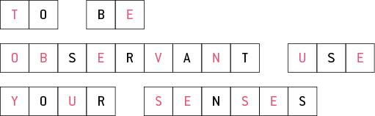

1.5 Science relies on measuring with accuracy

Literacy support worksheet answers (pages 10–13)

Measuring in the lab

1 Rearrange the letters of each of the words below to work out what is being measured.

a sams

mass

b tereprmueat

temperature

c dntcsaei

distance

d uvelmo

volume

e emit

time

2 Use the clues below to determine the unit of measurement.

a Equal to 100 cm

metre

b ‘Not’ spelled backwards

tonne

c I came first, she came third, you came where?

second

d 100 of these are equal to 1 metre

centimetre

e 60 minutes worth

hour

f Measurement inside the word ‘grammar’

gram

g Un-jumble the underlined words: the tiler relit the flame:

litre

h This unit sounds like ‘cagey’

kilogram (kg)

i This unit sounds like ‘degrease’ and tends to heat up

degrees

WORD DETECTIVE

3 Word search

Find as many words as possible in the puzzle below.

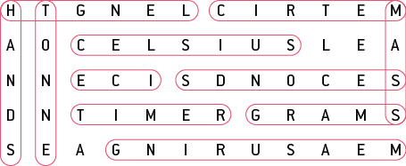

1.6 A Bunsen burner is an essential piece of laboratory equipment

Literacy support worksheet answers (pages 14–15)

Bunsen burners

1 Fill in the labels for the two Bunsen burner diagrams from the list below.

• Air hole open

• Air hole closed

• Heating flame

• Safety flame

Draw and colour in the flames in either blue or yellow.

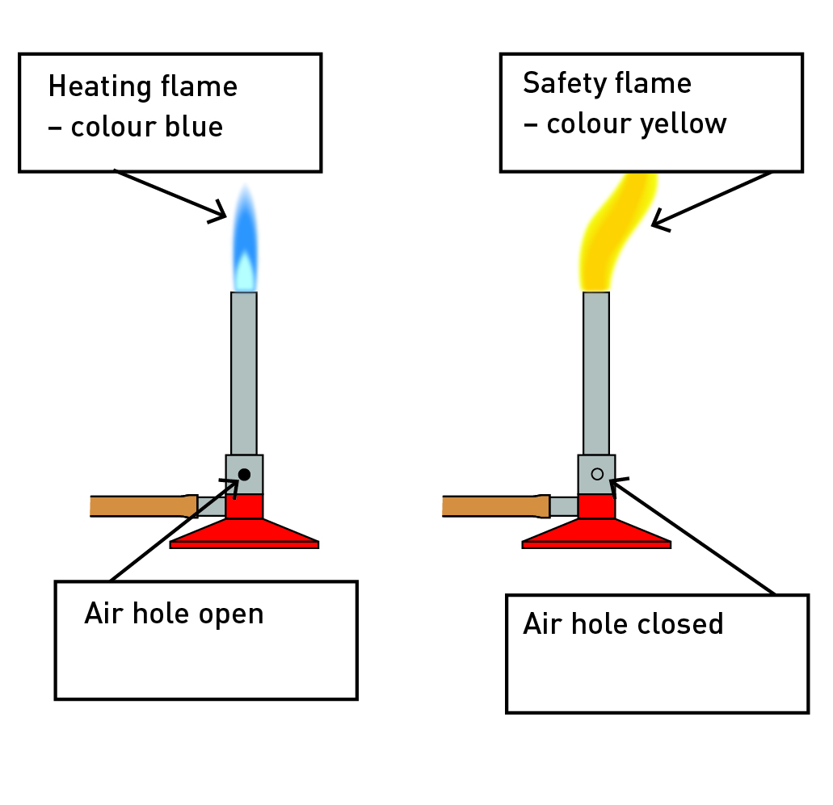

2 Write the numbers 1 to 6 next to the descriptions below so that the steps for lighting a Bunsen Burner are in order.

• Open the gas tap fully.

5

• Light a match and place it above the barrel, with your hand below the flame.

4

• Connect the rubber hosing firmly to the gas tap.

2

• Place the Bunsen burner on a heating mat.

1

• After you have followed these steps, the Bunsen burner will have a yellow flame.

6

• Close the air hole by turning the collar.

3

3 LPG is naturally odourless (you cannot smell it).

a Why do you think the gas supply companies add substances like hydrogen sulphide (rotten egg gas) to the LPG?

LPG contains rotten egg gas so you can smell it if there is a leak.

b What are two potential risks if the gas company did not add a smell to LPG?

Student response will vary but could include injury or death as a result of inhaling the gas, the potential of explosion because of a room filling with gas etc.

WORD DETECTIVE

4 Mumbo-jumbo

a Use the marked letters to find the secret word (e.g. olusntoi = solution).

b Unscramble each of the clue words below to find the message.

Secret word: SAFETY

Message: HEATING WITH A YELLOW FLAME LEAVES A SOOTY BLACK CARBON DEPOSIT

1.7 A fair test is a controlled experiment

Literacy support worksheet answers (pages 16–17)

Controls

1 Read the dot points below describing an experiment and answer the questions.

• Sue wanted to know what coloured shirt would keep her coolest

• She thought lighter colours would work best because her Mum’s white car was cooler inside than her Dad’s black car

• Sue found five coloured squares of cloth: white, purple, red, black, yellow and green

• She put the squares of cloth on the trampoline on a sunny day

• Sue put a thermometer under each cloth

• She recorded the initial temperature of the five thermometers

• Sue waited 5 minutes and wrote down the temperatures

• She repeated the experiment three more times and recorded her results.

a What was Sue’s hypothesis?

Sue’s hypothesis was ‘If the fabric is a lighter colour, then I will not get as hot’.

b What was the independent variable in Sue’s experiment?

The independent variable is colour of the cloth.

c What was the dependent variable in Sue’s experiment?

The dependent variable is the temperature measured under the different cloths.

d What variables were controlled in Sue’s investigation?

The position of the cloths and the thermometers, and the length of time in the Sun were the controlled variables.

e How did Sue attempt to improve the reliability of her investigation?

Sue repeated the experiment three times to improve the reliability of her results.

f Was Sue’s experiment a fair test? Why or why not?

Student responses may vary.

g How could Sue’s experiment be improved so her results are more reliable?

Student responses may vary, but could include different positioning of the cloths, reducing the effect of the breeze, performing the experiment more times etc.

WORD DETECTIVE

2 Draw and label

Draw and label Sue’s experiment using the words below.

Student answers will vary.

1.8 Graphs and tables are used to show results

Literacy support worksheet answers (pages 18–21)

Displaying results

1 Use the data in the results table to complete an appropriate graph in the space provided.

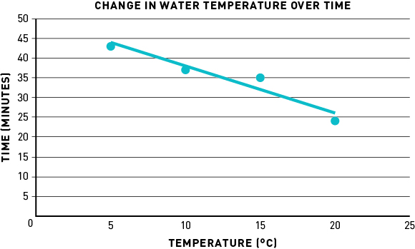

a What is the dependent variable?

Temperature

b What is the independent variable?

Time intervals

2 Look at the graph below and answer the following questions.

a What type of graph is this?

This is a column graph.

b Write a good title for this graph.

An appropriate title could be ‘Number of insects caught at different locations’ or something similar.

c What is the dependent variable?

Insects caught

d What is the independent variable?

Method of capture

e Which location had the highest number of insects caught?

B

f Which location had the lowest number of insects caught?

H

WORD DETECTIVE

3 Quick quiz

Answer the following questions using the list of words below:

a What type of data can only be whole numbers?

Discrete

b What kind of graph is usually used to show discrete data?

Column graph

c What type of data is the recording of times (e.g. for a 100 m race)?

Continuous

d What kind of graph should be used to show continuous data?

Scatter graph

e Besides a graph, what is another good way to show data?

Table

1.9 Scientific reports communicate findings

Literacy support worksheet answers (pages 22–23)

Reporting

1 Trying to remember the eight parts of a scientific report can be a challenge at first.

One way to remember the order is to create a mnemonic (using the first letter of each word to create new words to form a sentence).

For example, ‘*Tiny Ants Healed Moths Meanwhile Rats Drew Cats’*, where ‘tiny’ is for ‘title’, ‘ants’ is for ‘aim’, and so on.

Write your own mnemonic next to the eights parts of a scientific report listed below:

Student responses will vary depending on the mnemonic.

2 What are two different ways of writing the method?

In the present tense to plan what is going to be done and in the past tense in a formal report.

WORD DETECTIVE

3 Match-a-word

Draw a line from the word to its meaning

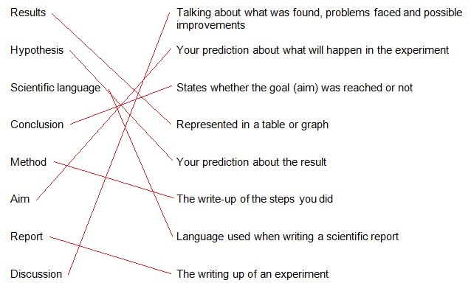

1.10 Science as a human endeavour: Science skills are used to solve important problems

Literacy support worksheet answers (pages 24–25)

Human endeavour

1 Design a simple experiment that scientists could conduct now that could investigate methods to control the population of carp in the waterways of the Murray–Darling Basin. Use pages 16 and 17 in the textbook to help you.

a What is the aim of your experiment?

Student responses will vary, but should relate to the control of the carp population.

b What are three ‘what if’ questions you could ask yourself before starting the experiment? (Think about location, methods to control the carp and predators.)

Student responses will vary, but examples include: ‘What if carp predators increased?’; ‘What if carp traps were set in degraded areas on the river?’; ‘What if fishing carp for financial reward was introduced in the Murray Darling Basin?’

c Write a hypothesis based on one of your three questions.

Student responses will vary.

d What experiment could you conduct to investigate your aim?

Student responses will vary, but should relate to the control of carp population.

e Write some of the equipment you may need to conduct the experiment.

Student responses will vary.

f How would you record your results?

Student responses will vary, but a table would be appropriate.

g How would you present your results?

Student responses will vary, but a graph and diagrams would be appropriate.

h What type of information would you include in your conclusion?

Student responses will vary, but they should be clear, reasoned and relate to the initial aim.

WORD DETECTIVE

2 Word search

Find the words listed, in the puzzle below.

